National University of Computer and Emerging Sciences



Lab Manual 08

AL2002-Artificial Intelligence Lab

|  |  |
| --- | --- |
| Course Instructor | Dr. Hajra Waheed |
| Lab Instructor (s) | Hamza Ayub  Muhammad Ahmed |
| Sections | B1 - B2 |
| Semester | Spring 2023 |

Department of Computer Science

FAST-NU, Lahore, Pakistan

Table of Contents

1 Objectives 3

2 Task Distribution 3

3 Anaconda (Python Distribution) 3

3.1 Installation Guide 4

4 Python Libraries for Data Science 4

4.1 Numpy 5

4.1.1 NumPy Installation 5

4.1.2 Arrays 5

4.1.3 Attributes of Array Object 7

4.1.4 Array Slicing and Indexing 8

4.1.5 Basic Array Operations 9

4.1.6 Datatypes 10

4.1.7 Input/Output Operations 11

4.2 Pandas 11

4.2.1 Pandas Installation 12

4.2.2 Series 12

4.2.3 Dataframe 13

4.2.4 Indexing 14

4.2.5 Input Output Operations 15

4.2.6 Other Operations 15

4.2.7 Retrieving Series/DataFrame Information 15

4.2.8 Application of Functions 16

5 Dataset Handling 16

5.1 Significance of Data 16

5.2 Types of Data Sets 16

5.2.1 Numerical Data Sets 17

5.2.2 Bivariate Data Sets 17

5.2.3 Multivariate Data Sets 17

5.2.4 Categorical Data Sets 17

5.2.5 Correlation Data Sets 17

5.3 Mean, Median, Mode and Range of Data-Sets 17

5.4 Types of Attributes 18

5.5 Properties of Dataset 18

5.6 Dataset Repositories 19

5.7 Properties of Attributes in a dataset 19

5.7.1 Missing Values 19

5.7.2 Outliers 19

5.8 Iris Flower Dataset 20

5.9 Load the Dataset 20

# Objectives

After performing this lab, students shall be able to understand the following Python concepts and applications:

* Anaconda Introduction
* Application of NumPy
* Application of Pandas
* Dataset handling

# Task Distribution

| **Total Time** | **170 Minutes** |
| --- | --- |
| Anaconda Introduction/Installation Guide | 20 Minutes |
| Application of NumPy | 20 Minutes |
| Application of Pandas | 20 Minutes |
| Dataset handling | 10 Minutes |
| Exercise | 90 Minutes |
| Online Submission | 10 Minutes |

# Anaconda (Python Distribution)

Anaconda is a distribution of the Python and R programming languages for scientific computing (data science, machine learning applications, large-scale data processing, predictive analytics, etc.). The distribution includes data-science packages suitable for Windows, Linux, and macOS. It is developed and maintained by Anaconda, Inc., which was founded by Peter Wang and Travis Oliphant in 2012.

**Anaconda Navigator**

Anaconda Navigator is a desktop [graphical user interface (GUI)](https://en.wikipedia.org/wiki/Graphical_user_interface) included in Anaconda distribution that allows users to launch applications and manage conda packages, environments and channels without using [command-line commands](https://en.wikipedia.org/wiki/Command-line_interface). Navigator can search for packages on Anaconda Cloud or in a local Anaconda Repository, install them in an environment, run the packages and update them. It is available for [Windows](https://en.wikipedia.org/wiki/Windows), [macOS](https://en.wikipedia.org/wiki/MacOS" \o "MacOS) and [Linux](https://en.wikipedia.org/wiki/Linux).

The following applications are available by default in Navigator:

* [JupyterLab](https://en.wikipedia.org/wiki/Project_Jupyter#JupyterLab)
* [Jupyter Notebook](https://en.wikipedia.org/wiki/Project_Jupyter#Jupyter_Notebook)
* QtConsole
* [Spyder](https://en.wikipedia.org/wiki/Spyder_(software))
* [Glue](https://en.wikipedia.org/wiki/Glue_(software))
* [Orange](https://en.wikipedia.org/wiki/Orange_(software))
* [RStudio](https://en.wikipedia.org/wiki/RStudio)
* [Visual Studio Code](https://en.wikipedia.org/wiki/Visual_Studio_Code)

## Installation Guide

For installing Anaconda Inc. you need to navigate to anaconda’s official website given here.

1. Choose your operating system (Windows/macOS/Linux) for installation from the top left panel.
2. Click on the link of the installer given on the page.
3. Press Download
4. Open executable file
5. Follow instructions in the set-up wizard
6. Run Anaconda Navigator

# Python Libraries for Data Science

Python is an easy-to-learn, easy-to-debug, widely used, object-oriented and open-source language. Python has been built with extraordinary libraries for data science that are used by programmers every day in solving problems. The top 10 Python libraries for data science include:

1. NumPy
2. Pandas
3. SciPy
4. TensorFlow
5. Matplotlib
6. Keras
7. SciKit-Learn
8. PyTorch
9. Scrapy
10. BeautifulSoup

## Numpy

NumPy (Numerical Python) is the fundamental package for numerical computation in Python; it contains a powerful N-dimensional array object. This is the foundation on which almost all the power of Python’s data science toolkit is built, and learning NumPy is the first step on any Python data scientist’s journey. NumPy also addresses the slowness problem partly by providing these multidimensional arrays as well as providing functions and operators that operate efficiently on these arrays. Here are the top four benefits that NumPy can bring to your code:

1. **More speed:** NumPy uses algorithms written in C that complete in nanoseconds rather than seconds.
2. **Fewer loops:** NumPy helps you to [reduce loops](https://realpython.com/numpy-array-programming/) and keep from getting tangled up in iteration indices.
3. **Clearer code:** Without loops, your code will look more like the equations you’re trying to calculate.
4. **Better quality:** There are thousands of contributors working to keep NumPy fast, friendly, and bug free.

If you are familiar with MATLAB, you can find some interesting stuff about NumPy here.

### NumPy Installation

* **Install NumPy with pip**

To install NumPy with **pip**, bring up a terminal window and type:

$ pip install numpy

This command installs NumPy in the current working Python environment.

* **Install Numpy in Anaconda**

For simple installation via Anaconda, you can follow the instructions given [here](https://docs.anaconda.com/anaconda/navigator/getting-started/#navigator-managing-packages).

**Import Convention**

To use numpy in the program we need to import the module. Generally, numpy package is defined as np of abbreviation for convenience. But you can import it using anything you want. The recommended convention to import numpy is:

**>>> import** **numpy** **as** **np**

### Arrays

A numpy array is a grid of values, all of the same type, and is indexed by a tuple of nonnegative integers.  The number of dimensions is the rank of the array; the shape of an array is a tuple of integers giving the size of the array along each dimension.

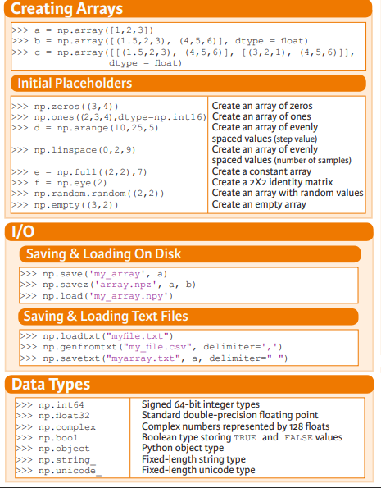

Figure 1 Array Creation

We can initialize numpy arrays from nested Python lists, and access elements using square brackets:

import numpy **as** np

a **=** np.array([1, 2, 3]) *# Create a rank 1 array*

Numpy also provides many functions to create arrays:

import numpy **as** np

a **=** np.zeros((2,2)) *# Create an array of all zeros*

**print**(a) *# Prints "[[ 0. 0.]*

*# [ 0. 0.]]"*

b **=** np.ones((1,2)) *# Create an array of all ones*

**print**(b) *# Prints "[[ 1. 1.]]"*

c **=** np.full((2,2), 7) *# Create a constant array*

**print**(c) *# Prints "[[ 7. 7.]*

*# [ 7. 7.]]"*

d **=** np.eye(2) *# Create a 2x2 identity matrix*

**print**(d) *# Prints "[[ 1. 0.]*

*# [ 0. 1.]]"*

e **=** np.random.random((2,2)) *# Create an array filled with random values*

**print**(e) *# Might print "[[ 0.91940167 0.08143941]*

*#0.68744134 0.87236687]]"*



Figure 2 Numpy Functions

For learning more ways of array creation check this out.

### Attributes of Array Object

ndarray.shape : The dimensions of the array. This is a tuple of integers indicating the size of the array in each dimension. For a matrix with n rows and m columns, shape will be(n,m) .

ndarray.ndim : The number of axes (dimensions) of the array.

ndarray.dtype : Retrieves the data type of array.

ndarray.itemsize : The size in bytes of each element of the array. For example, an array of elements of type float64 has *itemsize*8 (=64/8), while one of type *complex32*has itemsize 4 (=32/8). It is equivalent to *ndarray.dtype.itemsize.*

ndarray.size: The total number of elements of the array. This is equal to the product of the elements of shape.

import numpy **as** np

a **=** np.array([1, 2, 3]) *# Create a rank 1 array*

**print**(type(a)) *# Prints "<class 'numpy.ndarray'>"*

**print**(a.shape) *# Prints "(3,)"*

**print**(a[0], a[1], a[2]) *# Prints "1 2 3"*

a[0] **=** 5 *# Change an element of the array*

**print**(a) *# Prints "[5, 2, 3]"*

**print**(a.ndim) #Prints 1

**print**(len (a)) #Prints 3

b **=** np.array([[1,2,3],[4,5,6]]) *# Create a rank 2 array*

**print**(b.shape) *# Prints "(2, 3)"*

**print**(b[0, 0], b[0, 1], b[1, 0]) *# Prints "1 2 4"*

### ****Array Slicing and Indexing****

Similar to Python lists, numpy arrays can be sliced. Since arrays may be multidimensional, you must specify a slice for each dimension of the array:

import numpy **as** np

*# Create the following rank 2 array with shape (3, 4)*

*# [[ 1 2 3 4]*

*# [ 5 6 7 8]*

*# [ 9 10 11 12]]*

a **=** np.array([[1,2,3,4], [5,6,7,8], [9,10,11,12]])

*# Use slicing to pull out the subarray consisting of the first 2 rows*

*# and columns 1 and 2; b is the following array of shape (2, 2):*

*# [[2 3]*

*# [6 7]]*

b **=** a[:2, 1:3]

*# A slice of an array is a view into the same data, so modifying it*

*# will modify the original array.*

**print**(a[0, 1]) *# Prints "2"*

b[0, 0] **=** 77 *# b[0, 0] is the same piece of data as a[0, 1]*

**print**(a[0, 1]) *# Prints "77"*

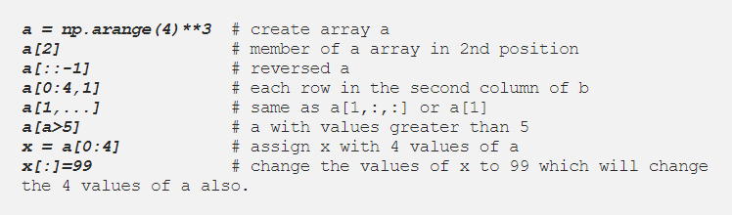

Figure 4 Indexing and Slicing Techniques

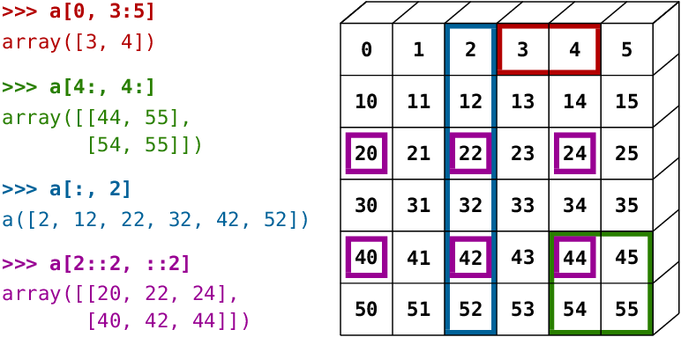

Figure 5 Indexing and slicing illustration using NumPy Array

### Basic Array Operations

Basic mathematical functions operate elementwise on arrays, and are available both as operator overloads and as functions in the numpy module:

import numpy **as** np

x **=** np.array([[1,2],[3,4]], dtype**=**np.float64)

y **=** np.array([[5,6],[7,8]], dtype**=**np.float64)

*# Elementwise sum; both produce the array*

*# [[ 6.0 8.0]*

*# [10.0 12.0]]*

**print**(x **+** y)

**print**(np.add(x, y))

*# Elementwise difference; both produce the array*

*# [[-4.0 -4.0]*

*# [-4.0 -4.0]]*

**print**(x **-** y)

**print**(np.subtract(x, y))

*# Elementwise product; both produce the array*

*# [[ 5.0 12.0]*

*# [21.0 32.0]]*

**print**(x **\*** y)

**print**(np.multiply(x, y))

*# Elementwise division; both produce the array*

*# [[ 0.2 0.33333333]*

*# [ 0.42857143 0.5 ]]*

**print**(x **/** y)

**print**(np.divide(x, y))

*# Elementwise square root; produces the array*

*# [[ 1. 1.41421356]*

*# [ 1.73205081 2. ]]*

**print**(np.sqrt(x))

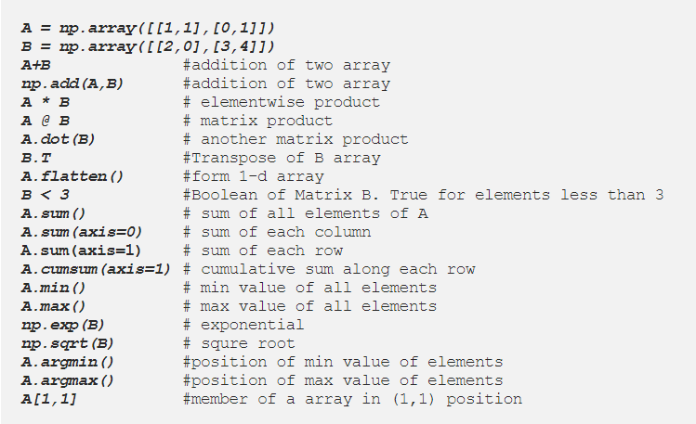

Figure 6 Array operations

### Datatypes

Every numpy array is a grid of elements of the same type. Numpy provides a large set of numeric datatypes that you can use to construct arrays. Numpy tries to guess a datatype when you create an array, but functions that construct arrays usually also include an optional argument to explicitly specify the datatype.

If you want to know the data type of an array, you can query the attributes of dtype. An object describing the type of the elements in the array. One can create or specify dtype using standard Python types.

Additionally, numpy provides types of its own. numpy.int32, numpy.int16, and numpy.float64 are some examples.



Figure 7 Data Types

Here is an example:

import numpy **as** np

x **=** np.array([1, 2]) *# Let numpy choose the datatype*

**print**(x.dtype) *# Prints "int64"*

x **=** np.array([1.0, 2.0]) *# Let numpy choose the datatype*

**print**(x.dtype) *# Prints "float64"*

x **=** np.array([1, 2], dtype**=**np.int64) *# Force a particular datatype*

**print**(x.dtype) *# Prints "int64"*

### Input/Output Operations



Figure 8 I/O operations

## Pandas

The Pandas library is one of the most preferred tools for data scientists to do data manipulation and analysis. It can work with data from a wide variety of sources. Pandas is suited for many different kinds of data: tabular data, time-series data, arbitrary matrix data with row and column labels, and any other form of observational/statistical data sets.

**Features:**

1. Enables you to create your own function and run it across a series of data
2. Contains high-level data structures and manipulation tools

### Pandas Installation

* **Installation via Terminal**

To install pandas in your system you can use this command pip install pandas or conda install pandas.

* **Installation in Anaconda**

Pandas or any other packages can be installed in Anaconda environment by following the tutorial here.

**Import Convention**

**>>> import** **pandas** **as** **pd**

### Series

Pandas series works the same way both in list and numpy array as well as dictionary. To make series in pandas we need to use pd.Series(data, index)format where data are input data and index are selected index for data. A one-dimensional labeled array capable of holding any data type:

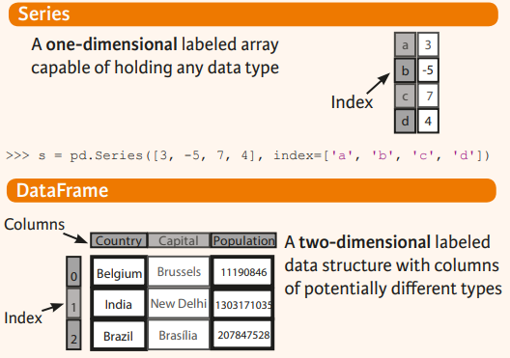

**>>> s = pd.Series([3, -5, 7, 4], index=['a', 'b', 'c', 'd'])**

|  |  |
| --- | --- |
| A | 3 |
|  |  |
| B | 5 |
|  |  |
| C | 7 |
|  |  |
| D | 4 |
|  |  |

Pandas series along with numPy array:

**import numpy as np**  #importing numpy  
**import pandas as pd** #importing pandas  
**arr=np.array([1,3,5,7,9])** #create arr array  
**s2=pd.Series(arr)** #create pandas series s2  
**print(s2)** #print s2  
**print(type(s2))** #print type of s2

**Output:**

0 1  
1 3  
2 5  
3 7  
4 9  
dtype: int64  
<class 'pandas.core.series.Series'>

### Dataframe

Pandas DataFrameisa way to store data in rectangular grids that can easily be overviewed. It’s like a tabular data structure with labeled axes (rows and columns). The default format of a DataFrame would be pd.Dataframe(data, index, column) . You need to mention the data, index and columns value to generate a DataFrame. Data should be at least two-dimensional, index will be the row name and columns values for the columns. In general, you could say that the Pandas DataFrame consists of three main components: the data, the index, and the columns.

The DataFrame can contain data that is:

1. Pandas DataFrame
2. Pandas Series: An example of a Series object is one column from a DataFrame.
3. a NumPy ndarray, which can be a record or structured
4. a two-dimensional ndarray
5. lists, dictionaries or Series.



**>>> data = {'Country': ['Belgium', 'India', 'Brazil'],**

**'Capital': ['Brussels', 'New Delhi', 'Brasilia'],**

**'Population': [11190846, 1303171035, 207847528]}**

**>>> df = pd.DataFrame(data,columns=['Country', 'Capital', 'Population'])**

To get subset of a Data Frame:

**>>> df[1:]**

**Country Capital Population**

**1 India New Delhi 1303171035**

**2 Brazil Brasilia 207847528**

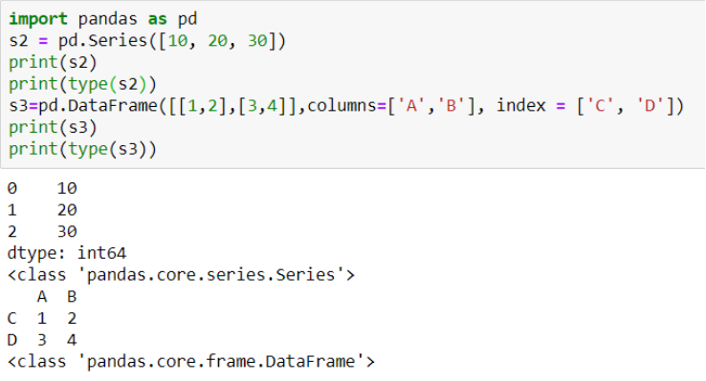

Figure 9 Example of Pandas Series and DataFrame

### Indexing

* .loc[] works on labels of your index. This means that if you give in loc[2], you look for the values of your DataFrame that have an index labeled 2.
* .iloc[] works on the positions in your index. This means that if you give in iloc[2], you look for the values of your DataFrame that are at index ‘2’.

### Input Output Operations

**Read and Write to CSV**

**pd.read_csv('file.csv', header=None, nrows=5)**

**df.to_csv('myDataFrame.csv')**

### Other Operations

* Set index a of Series s to 6

**>>> s['a'] = 6**

* Sort by the values along an axis

**>>> df.sort_values(by='Country')**

* Assign ranks to entries

**>>> df.rank()**

### Retrieving Series/DataFrame Information

* Basic Information (rows, columns)

**>>> df.shape**

* Describe index

**>>> df.index**

* Describe DataFrame columns

**>>> df.columns**

* Info on DataFrame

**>>> df.info()**

* Number of non-NA values

**>>> df.count()**

* Sum of values

**>>> df.sum()**

* Cumulative sum of values

**>>> df.cumsum()**

* Minimum/maximum values

**>>> df.min()/df.max()**

* Minimum/Maximum index value

**>>> df.idxmin()/df.idxmax()**

### Application of Functions

**>>> f = lambda x: x*2**

Apply function

**>>> df.apply(f)**

# Dataset Handling

## Significance of Data

A data set is a set or collection of data. This set is normally presented in a tabular pattern. Every column describes a particular variable. And each row corresponds to a given member of the data set, as per the given question. The data are essentially organized to a certain model that helps to process the needed information. This set of data is any permanently saved collection of information that usually contains either case-level, gathered data, or statistical guidance level data.

In Machine Learning projects, it is impossible for an “AI” to learn without data. During an AI development, we always rely on data. From training, tuning, model selection to testing, we use three different data sets: the training set, the validation set and the testing set.

* **Training data set**: The training data set is the one used to train an algorithm to understand how to apply concepts such as neural networks, to learn and produce results. It is the actual **data set** used to train the model for performing various actions. It includes both input data and the expected output.
* **Test data set**: The test data set is used to evaluate how well your algorithm was trained with the training data set. In AI projects, we can’t use the training data set in the testing stage because the algorithm will already know in advance the expected output which is not our goal.

## Types of Data Sets

In Statistics, we have different types of data sets available for different types of information. They are:

* Numerical data sets
* Bivariate data sets
* Multivariate data sets
* Categorical data sets
* Correlation data sets

Let us discuss all these data sets with examples.

### Numerical Data Sets

A set of all numerical data. It deals only with numbers. Some of the examples are;

* Weight and height of a person
* The count of RBC in a medical report
* Number of pages present in a book

### Bivariate Data Sets

A data set that has two variables is called a Bi-variate data set. It deals with the relationship between the two variables.

Example: To find the percentage score and age of the students in a class. Score and age can be considered as two variables.

### Multivariate Data Sets

A data set with multiple variables.

Example: If we have to measure the length, width, height, volume of a rectangular box, we have to use multiple variables to distinguish between those entities.

### Categorical Data Sets

Categorical data sets represent features or characteristics of a person or an object.

Example:

* A person’s gender (male or female)
* Marital status (married/unmarried)

### Correlation Data Sets

The set of values that demonstrate some relationship with each other indicates correlation data sets. Here the values are found to be dependent on each other.

Example: A tall person is considered to be heavier than a short person. So here the weight and height variables are dependent on each other.

## Mean, Median, Mode and Range of Data-Sets

The [mean, median and mode](https://byjus.com/maths/mean-median-mode/) along with range are the major topics in Statistics. Let us get through with respect to data-sets here.

**Mean of a data-set** is the average of all the observations present in the table. It is the ratio of the sum of observations to the total number of elements present in the data-set. The formula of mean is given by;

**Mean = Sum of Observations / Total Number of Elements in Data Set**

**Median of a data-set** is the middle value of the collection of data when arranged in ascending order and descending order.

**Mode of a data-set** is the variable or number or value which is repeated maximum number of times in the set.

**Range of a data set** is the difference between the maximum value and minimum value.

Range = Maximum Value – Minimum Value

**Example**:

Find the mean, mode, median and range of the given data set.

{2, 4, 6, 8, 2, 10, 12}

**Solution:**

Given, {2, 4, 6, 8, 2, 10, 12} is a set of data.

Mean = 2+4+6+8+2+10+12/7 = 44/7

To find median we have to first arrange the given data in ascending or descending order

So, {2,2,4,6,8,10,12}. Thus,

Median = 6

Mode = 2

Range = 12-2 = 10

## Types of Attributes

1. **Nominal**

Examples: ID numbers, eye color, zip codes

1. **Ordinal**

Examples: rankings (e.g., taste of potato chips on a scale from 1-10), grades, height in {tall, medium, short}

1. **Interval**

Examples: calendar dates, temperatures in Celsius or Fahrenheit.

1. **Ratio**

Examples: temperature in Kelvin, length, time, counts

## Properties of Dataset

Before performing any statistical analysis, it is essential to understand the nature of the data. We can use different Exploratory Data Analysis (EDA techniques), which helps to identify the properties of data, so that the appropriate statistical methods can be applied on the data. With the help of EDA techniques, we can check the following properties of the dataset.

* Centre of data
* Skewness of data
* Presence of outliers
* Correlation among the data

## Dataset Repositories

Datasets for analysis can be downloaded from common repositories like:

1. Kaggle
2. UCI

Check out this link for a list of various data repositories.

## Properties of Attributes in a dataset

### Missing Values

Some entries can be missing because of the following reasons:

1. **Data Extraction**: It is possible that there are problems with extraction process. In such cases, we should double-check for correct data with data guardians. Errors at data extraction stage are typically easy to find and can be corrected easily as well.
2. **Data collection**: These errors occur at time of data collection and are harder to correct.

### Outliers

Outlier is an observation that appears far away and diverges from an overall pattern in a sample. Let’s take an example, we do customer profiling and find out that the average annual income of customers is $1 lakh. But, there are two customers having annual income of $4 and $4.2 million. These two customers annual income is much higher than rest of the population. These two observations will be seen as Outliers.

Outliers can be due to the following reasons:

1. **Data Entry Errors:** Human errors such as errors caused during data collection, recording, or entry can cause outliers in data. For example: Annual income of a customer is $100,000. Accidentally, the data entry operator puts an additional zero in the figure. Now the income becomes $1,000,000 which is 10 times higher. Evidently, this will be the outlier value when compared with rest of the population.
2. **Measurement Error:**It is the most common source of outliers. This is caused when the measurement instrument used turns out to be faulty. For example: There are 10 weighing machines. 9 of them are correct, 1 is faulty. Weight measured by people on the faulty machine will be higher / lower than the rest of people in the group. The weights measured on faulty machine can lead to outliers.
3. **Experimental Error:** Another cause of outliers is experimental error. For example: In a 100m sprint of 7 runners, one runner missed out on concentrating on the ‘Go’ call which caused him to start late. Hence, this caused the runner’s run time to be more than other runners. His total run time can be an outlier.
4. **Data Processing Error:**Whenever we perform data mining, we extract data from multiple sources. It is possible that some manipulation or extraction errors may lead to outliers in the dataset.
5. **Sampling error:** For instance, we have to measure the height of athletes. By mistake, we include a few basketball players in the sample. This inclusion is likely to cause outliers in the dataset.

## Iris Flower Dataset

The Iris flower data set or Fisher's Iris data set is a multivariate data set introduced by the British statistician. The dataset contains 150 observations of iris flowers. There are four columns of measurements of the flowers in centimeters. The fifth column is the species of the flower observed. All observed flowers belong to one of three species. The data set consists of 50 samples from each of three species of Iris (Iris setosa, Iris virginica and Iris versicolor).

To gain more insights about this dataset check [this link](https://en.wikipedia.org/wiki/Iris_flower_data_set).

You can download this dataset from [here](https://www.kaggle.com/uciml/iris).

## Load the Dataset

In order to load the dataset, run Anaconda Navigator.

1. Launch Jupyter Notebook
2. Click on “Upload” button as shown in fig. 10
3. Select the dataset file from your directory
4. Create a new Python3 notebook by selecting “New” on the Jupyter host page
5. Follow the instructions given in the code snippet provided next

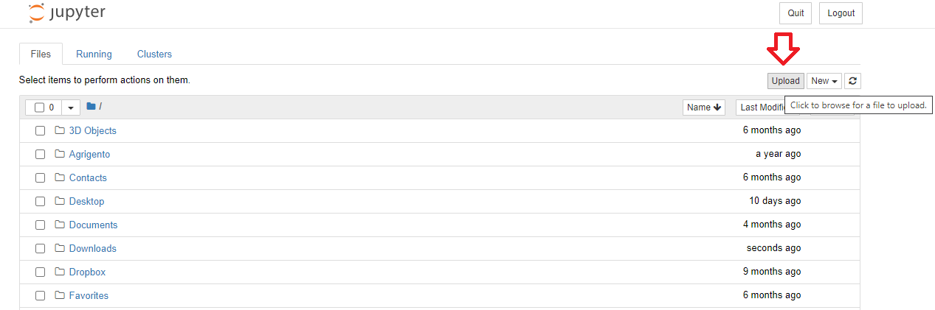

Figure 10 Load Dataset in Anaconda

Open the newly created notebook and implement the code given below:

import pandas as pd

iris_dataset= pd.read_csv("iris.csv")

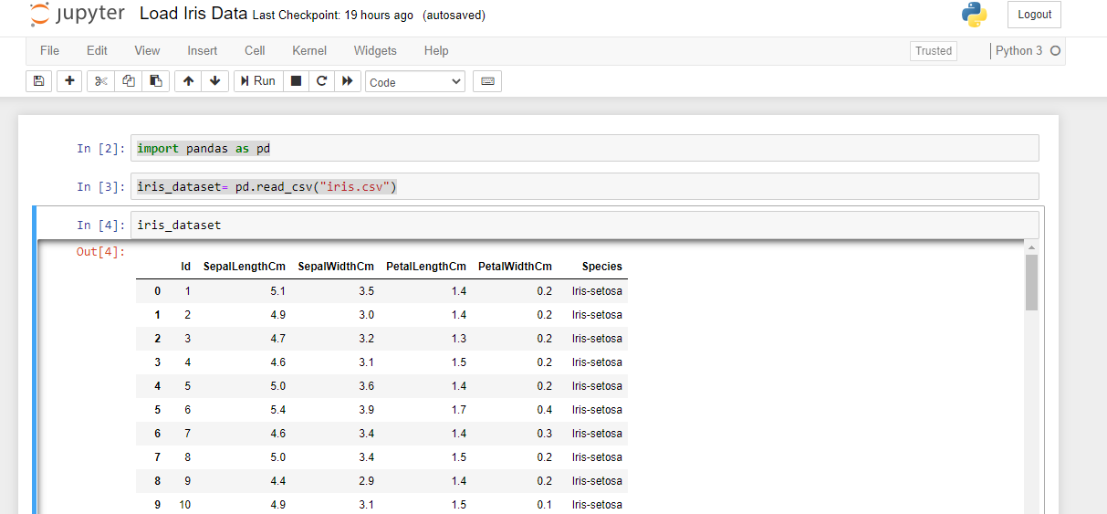iris_dataset

Figure 11 Code instructions

For more information about loading files, you can visit this site.